**DOCUMENTATION GLPI**



Adresse IP: 172.20.10.4

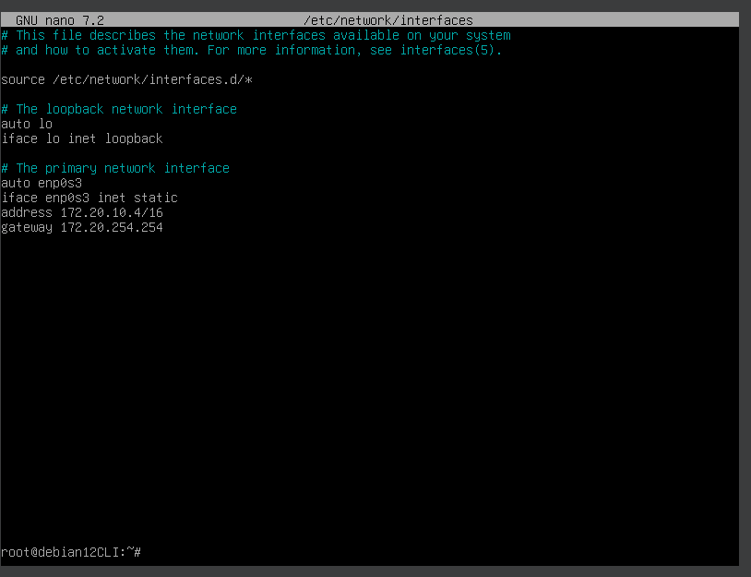

Installation des paquets php:



Ensuite : nano /etc/php/8.2/apache2/php.ini

Mettre dedans : session.cookie_httponly = on

Redemarrer avec systemctl restart apache2

**Installation du paquet mariadb :**

1: apt-get install apt-transport-https curl

2: mkdir -p /etc/apt/keyrings curl -o /etc/apt/keyrings/mariadb-keyring.pgp '<https://mariadb.org/mariadb_release_signing_key.pgp>'

3: nano /etc/apt/sources.list.d/mariadb.sources

4: copier coller en enlevant les espaces:

# MariaDB 11.4 repository list - created 2025-01-13 07:58 UTC # <https://mariadb.org/download/>

X-Repolib-Name: MariaDB

Types: deb

# deb.mariadb.org is a dynamic mirror if your preferred mirror goes offline. See <https://mariadb.org/mirrorbits/> for details. # URIs: <https://deb.mariadb.org/11.4/debian> URIs: <https://mirrors.ircam.fr/pub/mariadb/repo/11.4/debian>

Suites: bookworm

Components: main

Signed-By: /etc/apt/keyrings/mariadb-keyring.pgp

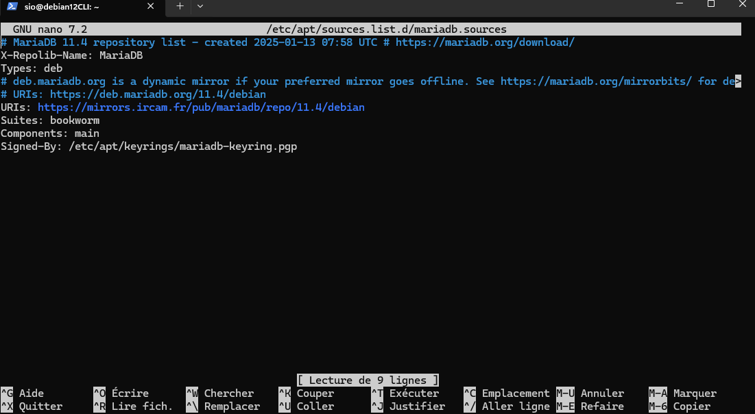

Effectuer ces deux commandes

apt-get update

apt-get install mariadb-server

**Mise en place de la base de données avec utilisateur :**

mysql -u root

CREATE DATABASE glpidbz;

CREATE USER 'glpiuser1'@'localhost' IDENTIFIED BY 'glpi123';

GRANT ALL PRIVILEGES ON glpidbz.* TO 'glpiuser1'@'localhost';

FLUSH PRIVILEGES;

Exit

**Configuration de apache2 :**

apt install sudo

nano /etc/apache2/sites-available/000-default.conf

(copier-coller):

<VirtualHost *:80>

ServerName 172.20.10.4

DocumentRoot /var/www/glpi/public

# If you want to place GLPI in a subfolder of your site (e.g. your virtual host is serving multiple applications),

# you can use an Alias directive. If you do this, the DocumentRoot directive MUST NOT target the GLPI directory itself.

# Alias "/glpi" "/var/www/glpi/public"

<Directory /var/www/glpi/public>

Require all granted

RewriteEngine On

# Ensure authorization headers are passed to PHP.

# Some Apache configurations may filter them and break usage of API, CalDAV, ...

RewriteCond %{HTTP:Authorization} ^(.+)$

RewriteRule .* - [E=HTTP_AUTHORIZATION:%{HTTP:Authorization}]

# Redirect all requests to GLPI router, unless file exists.

RewriteCond %{REQUEST_FILENAME} !-f

RewriteRule ^(.*)$ index.php [QSA,L]

</Directory>

</VirtualHost>

Ensuite faites :

sudo a2enmod rewrite && sudo service apache2 restart

systemctl restart apache2

Installation de GLPI:

cd /var/www/

wget [https://github.com/glpi-project/glpi/releases/download/10.0.18/glpi-10.0.18.tgz](https://github.com/glpi-project/glpi/releases/download/10.0.17/glpi-10.0.17.tgz)

tar -xvzf glpi-10.0.18.tgz

rm glpi-10.0.18.tgz

chown -R www-data /var/www/glpi

**ACCES WEB :**

**Suivre les étapes des captures d’écran**



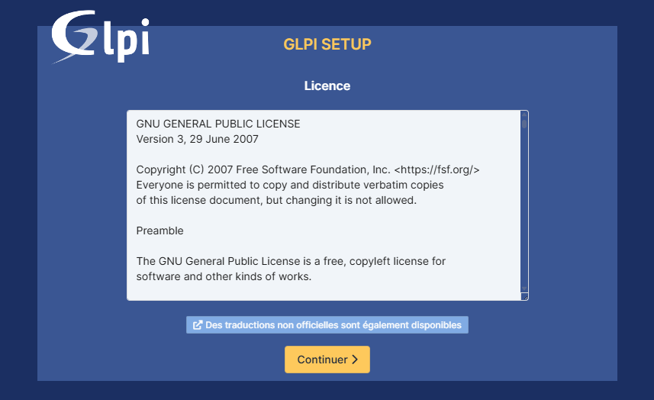

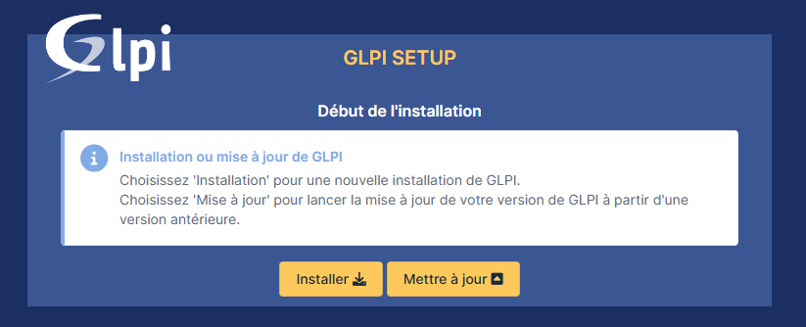

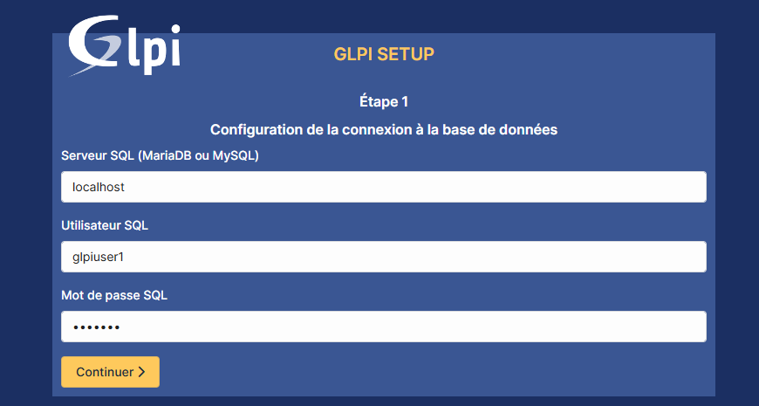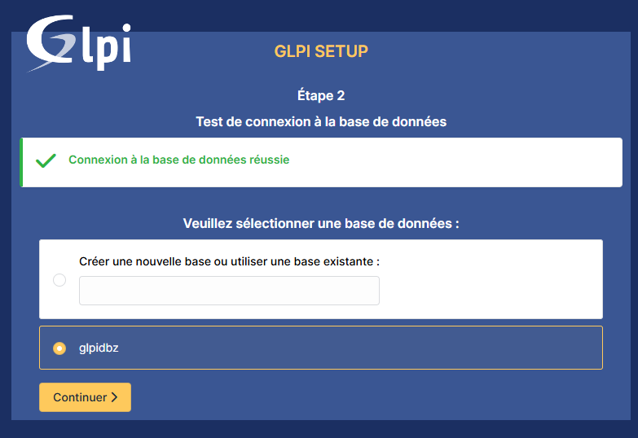

Attendre la fin de l’installation 

Identifiant : glpi

Mot de passe : glpi

GLPI EST INSTALLÉ !

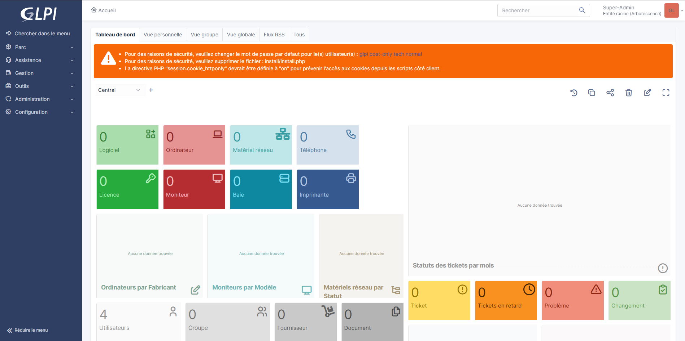Pensez à activer l’inventaire et à sauvegarder

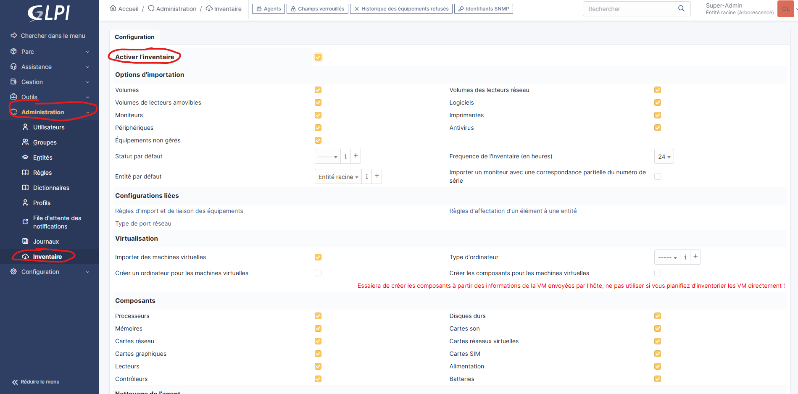

**Enlever les erreurs de sécurité :**

1:



Sur le serveur faire :

cd /var/www/glpi/install/

rm install.php

systemctl restart apache2

2:

Acceder ici :

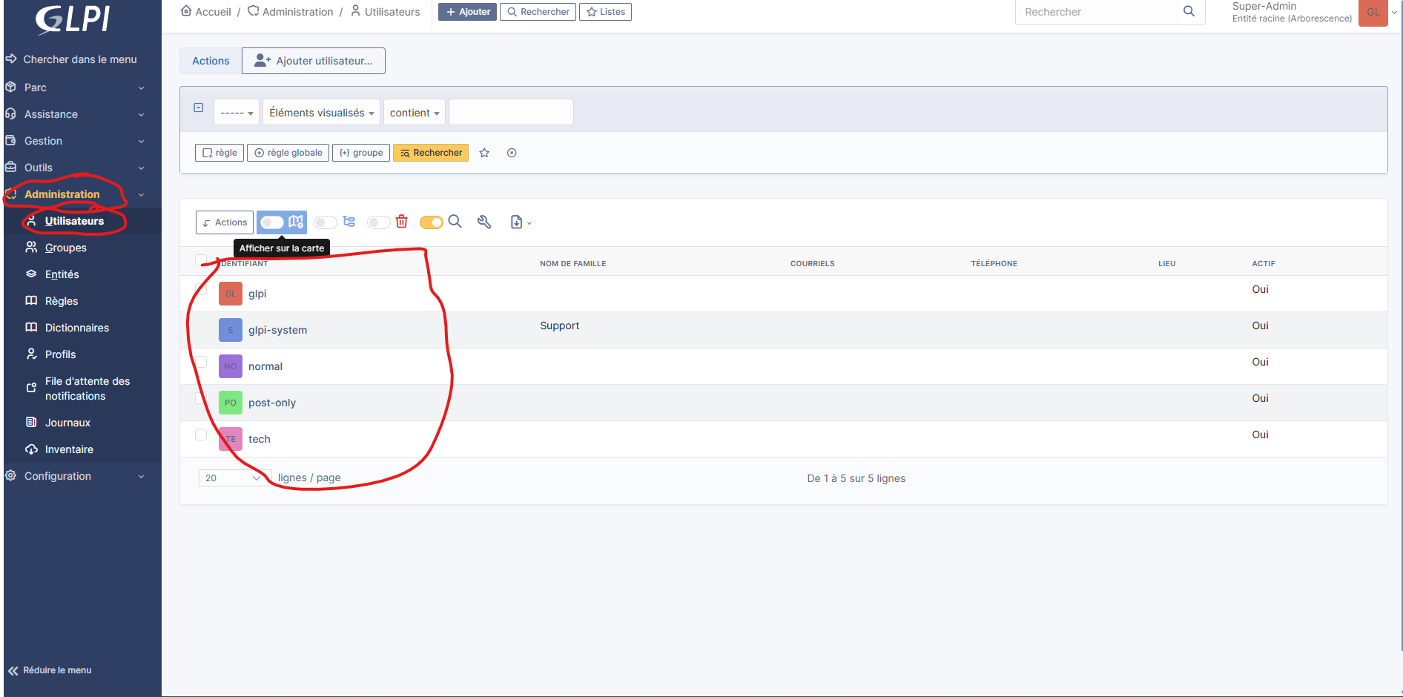**Utilisateur GLPI :**

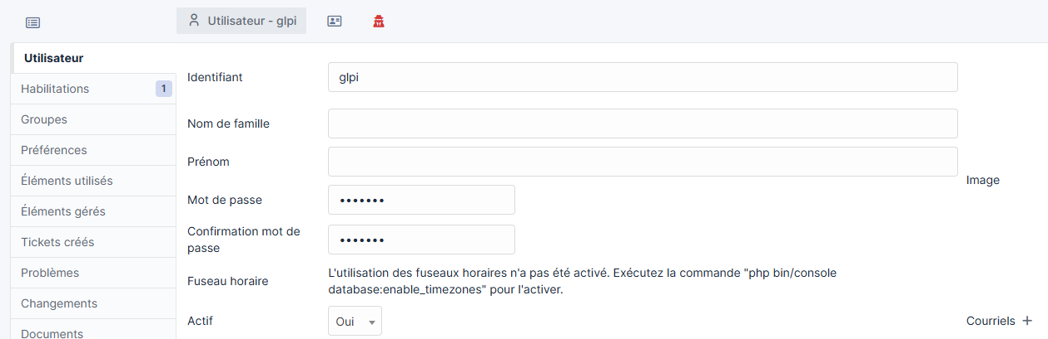Mdp: glpi123

**Utilisateur post-only :**

Mdp: post-only123

**Utilisateur tech :**

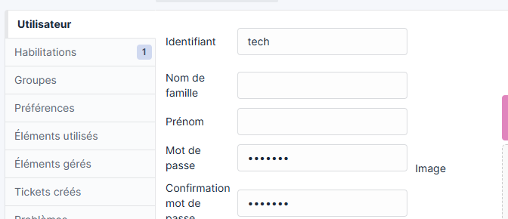

Mdp: tech123

**Utilisateur normal :**

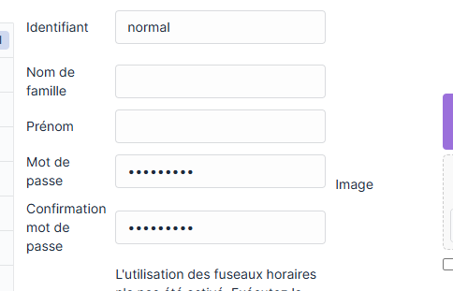

Mdp: normal123

Voilà, GLPI est installer et configurer !